Design Activity 2

Kausik N

COE17B010

**Introduction:**

**Pipelining is a performance improvement technique by which we arrange the hardware such that more than one operation can be performed at the same time.**

**We do this by splitting the overall hardware into a series of submodules and attaching flip flops in between those stages. So, with each clock cycle inputs get processed by the stage and get stored in their respective stage flip flops. Thus, we can feed inputs as a series and outputs come out in 1 clock cycle itself.**

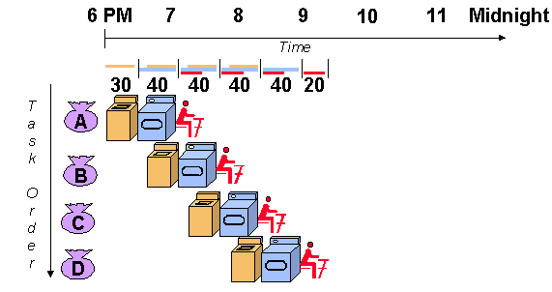

**Primitive Gate Delay Values:**

|  |  |
| --- | --- |
| **Logic gates** | **Delay considered (In Gate Delay Units)** |
| NOT | **1** |
| AND | **1** |
| OR | **1** |
| NAND | **2** |
| NOR | **2** |
| XOR | **2** |
| MUX | **1** |

**16-bit Adder**

**Design:**

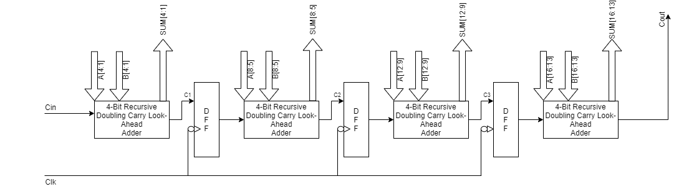

**Analysis:**

1. **Number of pipeline stages: 4**

|  |  |
| --- | --- |
| **Stage 1** | First 4 Bits Addition [4:1] |
| **Stage 2** | Second 4 Bits Addition [8:5] |
| **Stage 3** | Third 4 Bits Addition [12:9] |
| **Stage 4** | Last 4 Bits Addition [16:13] |

1. **Logic components:**

|  |  |  |
| --- | --- | --- |
| **Stages** | **Logic components involved (Number)** | **Total Delay (delay)** |
| Stage 1 | AND (14), XOR (4), NOT (6), NAND (4), NOR (8) | NOR (2) + AND (1) + NOR (2) + XOR (2) = 7 |
| Stage 2 | AND (14), XOR (4), NOT (6), NAND (4), NOR (8) | NOR (2) + AND (1) + NOR (2) + XOR (2) = 7 |
| Stage 3 | AND (14), XOR (4), NOT (6), NAND (4), NOR (8) | NOR (2) + AND (1) + NOR (2) + XOR (2) = 7 |
| Stage 4 | AND (14), XOR (4), NOT (6), NAND (4), NOR (8) | NOR (2) + AND (1) + NOR (2) + XOR (2) = 7 |

1. **Calculations:**

**Exe Time Pipeline = (No. of Stages + No. of operations - 1) * Delay of 1 clock cycle**

Here, Delay of 1 clock cycle = Max. (limiting) Stage Delay = **7** Gate Delay Units

No. of Stages = 4

Consider No. of operations = 100,

ET-Pipeline = (4 + 100 - 1) * 7 = **721** Gate Delay Units

**Exe Time Non-Pipeline = (No. of operations) * Delay of Longest Path**

= 100 * (7 * 4) = **2800** Gate Delay Units

**Efficiency = Given Speedup / Max Speedup**

In ideal case, Max. Speedup = No. of Stages

Efficiency-Pipeline = ((No of operations * No of Stages) / (No of Stages + No of operations - 1)) / No of Stages

= ((100*4) / (100+4-1)) / 4 = 100/103 = **0.97**

**Throughput = No of operations / Execution Time**

Throughput-Pipeline = 100 / 721 = **0.139** operations per gate delay

Throughput-Non-Pipeline = 100 / 2800 = **0.036** operations per gate delay

1. **Comparison:**

|  |  |  |
| --- | --- | --- |
| **Factors** | **Non-Pipelined** | **Pipelined** |
| Extra hardware | No | Extra DFFs, clock wiring, clock generation hardware |
| Cost | Less | More cost due to extra hardware |
| Area on chip | Less | More area due to extra components |
| Execution time (For 100 operations in Gate Delay Units) | 2800 | 721 |
| Power required | Less | High due to extra DFFs |
| Complexity | Less | More due to more connections and logical circuits |
| Efficiency | - | 0.97 |
| Throughput | 0.036 | 0.139 |

1. **Speedup:**

Speedup from pipelining = Average execution time unpipelined

Average execution time pipelined

= 2800 / 721 = **3.88**

**16-bit Wallace Multiplier**

**Design:**

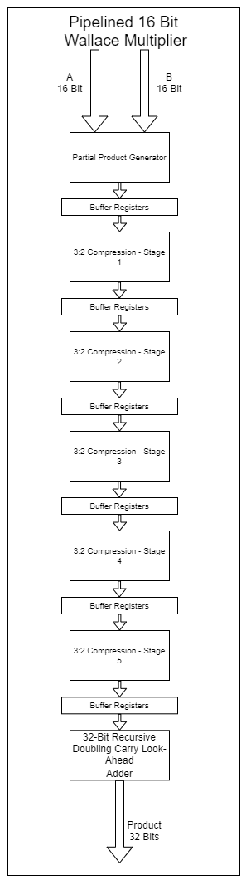

**Analysis:**

1. **Number of pipeline stages: 7**

|  |  |
| --- | --- |
| **Stage 1** | Partial Product Generation |
| **Stage 2** | 3:2 Compression |
| **Stage 3** | 3:2 Compression |
| **Stage 4** | 3:2 Compression |
| **Stage 5** | 3:2 Compression |
| **Stage 6** | 3:2 Compression |
| **Stage 7** | 32-Bit Addition |

1. **Logic components:**

Half adder: XOR (1), AND (1)

Delay = XOR (2) = 2

Full adder: XOR (2), AND (2), OR (1)

Delay = XOR (2) + AND (1) + OR (1) = 4

|  |  |  |
| --- | --- | --- |
| **Stages** | **Logic components involved (Number)** | **Total Delay**  **(delay)** |
| Stage 1 | AND (256) | AND (1) |
| Stage 2 | Half Adder (2), Full Adder (14) | Full Adder (4) |
| Stage 3 | Half Adder (2), Full Adder (14) | Full Adder (4) |
| Stage 4 | Half Adder (2), Full Adder (14) | Full Adder (4) |
| Stage 5 | Half Adder (2), Full Adder (14) | Full Adder (4) |
| Stage 6 | Half Adder (2), Full Adder (14) | Full Adder (4) |
| Stage 7 | 32-bit RD CLA | 7*8 = 56 |

1. **Calculations:**

**Exe Time Pipeline = (No. of Stages + No. of operations - 1) * Delay of 1 clock cycle**

Here, Delay of 1 clock cycle = Max. (limiting) Stage Delay = **56** Gate Delay Units

No. of Stages = 7

Consider No. of operations = 100,

ET-Pipeline = (7 + 100 - 1) * **56** = **5936** Gate Delay Units

**Exe Time Non-Pipeline = (No. of operations) * Delay of Longest Path**

= 100 * (1 + 4 + 4 + 4 + 4 + 4 + 56) = **7700** Gate Delay Units

**Efficiency = Given Speedup / Max Speedup**

In ideal case, Max. Speedup = No. of Stages

Efficiency-Pipeline = ((No of operations * No of Stages) / (No of Stages + No of operations - 1)) / No of Stages

= ((100*7) / (100+7-1)) / 7 = 100/106 = 0.94

**Throughput = No of operations / Execution Time**

Throughput-Pipeline = 100 / 5936 = 0.017 operations per gate delay

Throughput-Non-Pipeline = 100 / 7700 = 0.013 operations per gate delay

1. **Comparison:**

|  |  |  |
| --- | --- | --- |
| **Factors** | **Non-Pipelined** | **Pipelined (Design 2)** |
| Extra hardware | No | Extra DFFs, clock wiring, clock generation hardware |
| Cost | Less | More cost due to extra hardware |
| Area on chip | Less | More area due to extra components |
| Execution time (For 100 operations in Gate Delay Units) | 7700 | 5936 |
| Power required | Less | High due to extra DFFs |
| Complexity | Less | More due to more connections and logical circuits |
| Efficiency | - | 0.94 |
| Throughput | 0.013 | 0.017 |

1. **Speedup:**

Speedup from pipelining = Average execution time unpipelined

Average execution time pipelined

= 7700 / 5936 = **1.29**

**Half Precision Floating Point Adder**

**Design:**

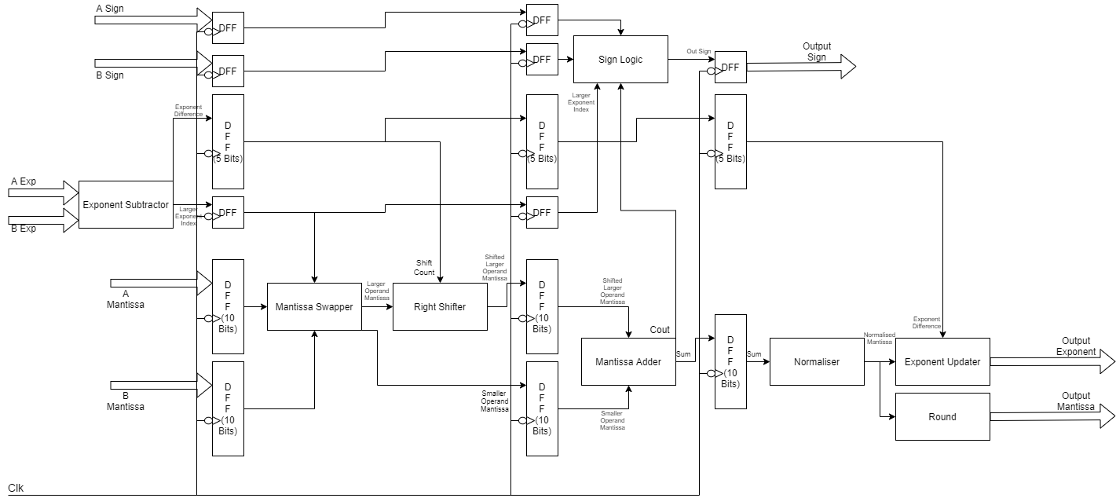

**Analysis:**

1. **Number of pipeline stages: 4**

|  |  |
| --- | --- |
| **Stage 1** | Exponent Subtraction - Detect Larger Exponent |
| **Stage 2** | Swap Mantissa & Right Shift larger value |
| **Stage 3** | Sign Logic & Add Mantissas |
| **Stage 4** | Renormalize & Round Output Mantissa and Update Output Exponent |

1. **Logic components:**

|  |  |  |
| --- | --- | --- |
| **Stages** | **Logic components involved (Number)** | **Total Delay**  **(delay)** |
| Stage 1 | NOT (5), 8-Bit CLA (1) | NOT (1) + Adder (14) = 15 |
| Stage 2 | 2:1 MUX (1), 10-Bit Barrel Shifter (1) | MUX (1) + Shifter (1) = 2 |
| Stage 3 | 16-Bit CLA (1), Sign Logic (1) | Adder (28) + Sign Logic (1) = 29 |
| Stage 4 | 16-Bit Priority Encoder (1), 10-Bit Barrel Shifter, 8-Bit CLA (1) | Priority Encoder (5) + Shifter (1) + Adder (14) = 20 |

1. **Calculations:**

**Exe Time Pipeline = (No. of Stages + No. of operations - 1) * Delay of 1 clock cycle**

Here, Delay of 1 clock cycle = Max. (limiting) Stage Delay = **29** Gate Delay Units

No. of Stages = 4

Consider No. of operations = 100,

ET-Pipeline = (4 + 100 - 1) * 29 = **2987** Gate Delay Units

**Exe Time Non-Pipeline = (No. of operations) * Delay of Longest Path**

= 100 * (15 + 2 + 29 + 20) = **6600** Gate Delay Units

**Efficiency = Given Speedup / Max Speedup**

In ideal case, Max. Speedup = No. of Stages

Efficiency-Pipeline = ((No of operations * No of Stages) / (No of Stages + No of operations - 1)) / No of Stages

= ((100*4) / (100+4-1)) / 4 = 100/103 = 0.97

**Throughput = No of operations / Execution Time**

Throughput-Pipeline = 100 / 2987 = 0.033 operations per gate delay

Throughput-Non-Pipeline = 100 / 6600 = 0.015 operations per gate delay

1. **Comparison:**

|  |  |  |
| --- | --- | --- |
| **Factors** | **Non-Pipelined** | **Pipelined** |
| Extra hardware | No | Extra DFFs, clock wiring, clock generation hardware |
| Cost | Less | More cost due to extra hardware |
| Area on chip | Less | More area due to extra components |
| Execution time (For 100 operations in Gate Delay Units) | 6600 | 2987 |
| Power required | Less | High due to extra DFFs |
| Complexity | Less | More due to more connections and logical circuits |
| Efficiency | - | 0.97 |
| Throughput | 0.015 | 0.033 |

1. **Speedup:**

Speedup from pipelining = Average execution time unpipelined

Average execution time pipelined

= 6600 / 2987= **2.21**

**Half Precision Floating Point Multiplier**

**Design:**

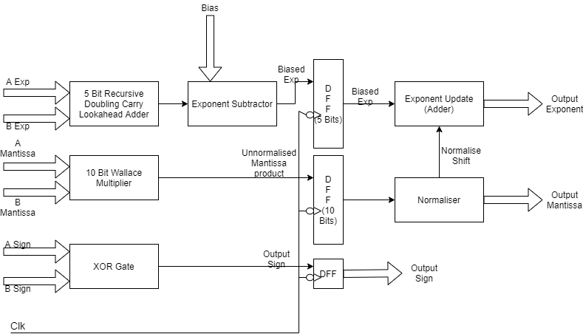

**Analysis:**

1. **Number of pipeline stages: 2**

|  |  |
| --- | --- |
| **Stage 1** | Exponent Addition & Mantissa Multiplication & Sign Logic |
| **Stage 2** | Normalization and Exponent Updation |

1. **Logic components:**

|  |  |  |
| --- | --- | --- |
| **Stages** | **Logic components involved (Number)** | **Total Delay**  **(delay)** |
| Stage 1 | 8-Bit CLA (2), 16-Bit Wallace Multiplier (1), XOR (1) | Multiplier (77) |
| Stage 2 | 16-Bit Priority Encoder (1), 10-Bit Barrel Shifter, 8-Bit CLA (1) | Priority Encoder (5) + Shifter (1) + Adder (14) = 20 |

1. **Calculations:**

**Exe Time Pipeline = (No. of Stages + No. of operations - 1) * Delay of 1 clock cycle**

Here, Delay of 1 clock cycle = Max. (limiting) Stage Delay = **77** Gate Delay Units

No. of Stages = 2

Consider No. of operations = 100,

ET-Pipeline = (2 + 100 - 1) * 77 = **7777** Gate Delay Units

**Exe Time Non-Pipeline = (No. of operations) * Delay of Longest Path**

= 100 * (77 + 20) = **9700** Gate Delay Units

**Efficiency = Given Speedup / Max Speedup**

In ideal case, Max. Speedup = No. of Stages

Efficiency-Pipeline = ((No of operations * No of Stages) / (No of Stages + No of operations - 1)) / No of Stages

= ((100*2) / (100+2-1)) / 2 = 100/101 = 0.99

**Throughput = No of operations / Execution Time**

Throughput-Pipeline = 100 / 7777 = 0.013 operations per gate delay

Throughput-Non-Pipeline = 100 / 9700 = 0.010 operations per gate delay

1. **Comparison:**

|  |  |  |
| --- | --- | --- |
| **Factors** | **Non-Pipelined** | **Pipelined** |
| Extra hardware | No | Extra DFFs, clock wiring, clock generation hardware |
| Cost | Less | More cost due to extra hardware |
| Area on chip | Less | More area due to extra components |
| Execution time (For 100 operations in Gate Delay Units) | 9700 | 7777 |
| Power required | Less | High due to extra DFFs |
| Complexity | Less | More due to more connections and logical circuits |
| Efficiency | - | 0.99 |
| Throughput | 0.010 | 0.013 |

1. **Speedup:**

Speedup from pipelining = Average execution time unpipelined

Average execution time pipelined

= 9700 / 7777 = **1.25**